A Project on

***HOSTEL MANAGEMENT SYSTEM***

Submitted by

**CHAITANYA PUNJA**

Kalinga Institute of Industrial Technology

Ref. No. HCE/SIP/429/2023

*Under The Guidance of*

**Mr. Deepak Kumar Pal**Manager(Systems)

Nalco Bhawan, P/1, Nayapalli,

Bhubaneswar



Corporate System Department,

National Aluminium Company Limited,

Nalco Bhawan, P/1, Nayapalli,

Bhubaneswar

Department Of Corporate System

NALCO BHAWAN, P/1, NAYAPALLi, BHUBANESWAR

**Certificate**

This is to certify that the project titled "Hostel Management System" submitted by Chaitanya Punja (Ref. No. HCE/SIP/429/2023) from Kalinga Institute of Industrial Technology. This project report is submitted in partial fulfillment for the requirement of the certificate of completion under

Date: 19-07-2023

**Project Guide**

**Mr. Deepak Kumar Pal**

Manager(Systems)

Nalco Bhawan, P/1, Nayapalli,

Bhubaneswar.

**Declaration**

We hereby declare that the work contained in the report is original and has been done by us under the general supervision of our project guide. The result has not been submitted to any other institute for any degree or diploma. We have followed the guidelines provided by the institute in writing the report. We have conformed to the norms and policies given in the Ethical Code of Conduct of the institute. Whenever we have used the material(data, theoretical analysis, figures, etc.) from other resources, we have given due credit to them by citing them in the text of the report and providing their details in the references. Whenever we have quoted written materials from other sources, we put them under quotation marks and give them due credit to the sources by citing them and giving required references.

**Chaitanya Punja**

Kalinga Institute Of Industrial Technology

Ref.No. HCE/SIP/429/2023

**Acknowledgement**

We would like to express our sincere regards and profound sense of gratitude to those who have helped us in completing this project successfully. At the very outset, our special and heartfelt thanks to our guide Mr. Deepak Kumar Pal Manager(Systems), Nalco Bhawan, Bhubaneswar for his precious guidance, assistance and constant supervision to bring this piece of work into the present form and for the opportunity to present this project.

**Chaitanya Punja**

Ref.No. HCE/SIP/429/2023

## **Abstract**

As the name implies, "HOSTEL MANAGEMENT SYSTEM" is a piece of software designed to manage numerous operations in the hostel. The number of educational institutions has been substantially expanding in recent years. As a result, the number of rooms available for students studying at this university is growing. As a result, the person running the hostel is under a lot of strain, and software is not typically used in this setting. This project addresses the issues associated with hostel management while avoiding the issues that arise when manual tasks are performed. The identification of the shortcomings of the present system leads to the creation of a computerized system that will be compatible with the old system while being more user friendly and GUI oriented.

**Keywords:** GUI, computerized system, SRS.

**Contents**

Certificate i

Acknowledgement ii

Declaration iii

Abstract iv

1 Introduction

1.2 Advantages

2 About the Project

2.1 Software Configuration

2.2 Language Specification

3 My Contribution

4 Conclusion

5 References

**List of Figures**

Fig 1.: Application flow and level-3 Data Flow Diagram

Fig 2.: Entity-Relationship Diagram of Hostel Management System

**List of Tables**

1. Hostel Table
2. Student Login Table
3. Staff Login Table
4. Room Request Table
5. Payment Details Table
6. Staff Details Table
7. Student Details Table

**1. Introduction**

As the name implies, "HOSTEL MANAGEMENT SYSTEM" is a piece of software designed to manage numerous operations in the hostel. The number of educational institutions has been substantially expanding in recent years. As a result, the number of dormitories available for students studying at this university is growing. As a result, the person running the hostel is under a lot of strain, and software is not typically used in this setting.

This project addresses the issues associated with hostel management while avoiding the issues that arise when manual processes are used. The identification of the shortcomings of the present system leads to the creation of a computerized system that will be compatible with the old system while being more user friendly and GUI oriented. We can improve the system's efficiency and thereby overcome the shortcomings of the current system.

**1.2 Advantages**

• Less human error

• Strength and strain of manual labor can be reduced

• High security

• Data redundancy can be avoided to some extent

• Data consistency

• Easy to handle

• Easy data updating

• Easy record keeping

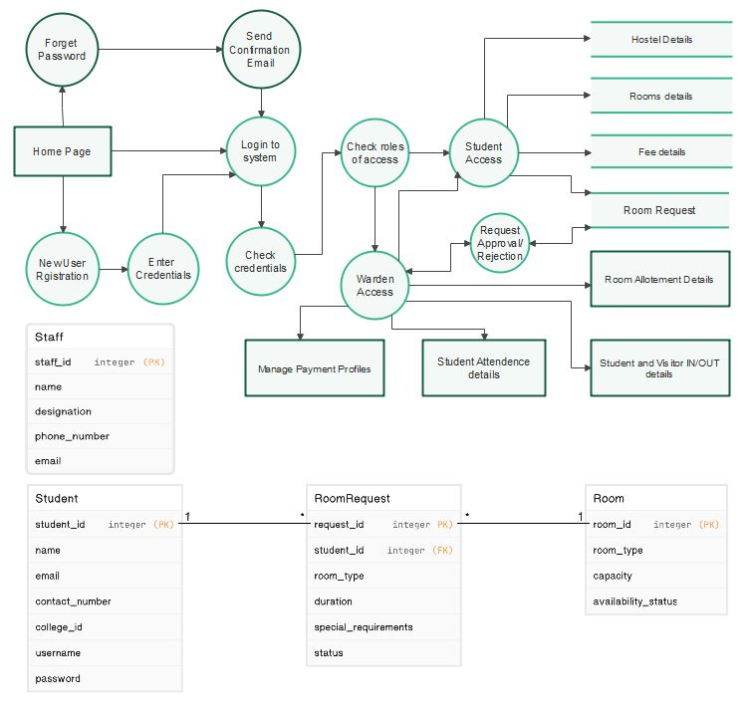

Fig1.: Application flow along with level-3 Data Flow Diagram

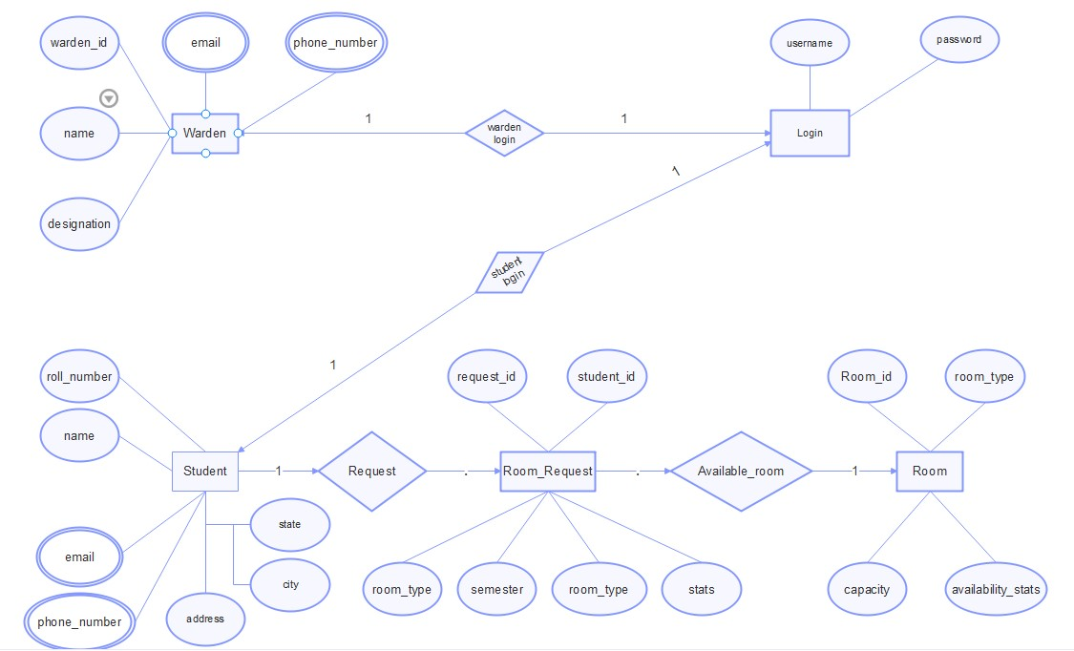

Fig2.: Entity-Relationship Diagram of Hostel Management System

**2. About the project**

**2.1 Software Configuration**

Operating System - Windows

Application Server - XAMPP V3.2.2 and VS code

Front End - HTML, Bootstrap, CSS

Server sides Script - PHP

Database - Mysql

**2.2 Language Specification**

There are three main areas where PHP scripts are used.

**➢ Server-side scripting:**

This is the most traditional and main target field for PHP. You need three things to make this work. The PHP parser (CGI or server module), a web server and a web browser.

**➢ Command line scripting:**

You can make a PHP script to run it without any server or browser. You only need the PHP parser to use it this way.

**➢ Writing desktop applications:**

PHP is probably not the very best language to create a desktop application with a graphical user interface, but if you know PHP very well, and would like to use some advanced PHP features in your client-side applications you can also use PHP-GTK to write such programs. You also have the ability to write cross-platform applications this way.

PHP can be used on all major operating systems, including Linux, many Unix variants (including HP-UX, Solaris and OpenBSD), Microsoft Windows, Mac OS X, RISC OS, and probably others. PHP also has support for most of the web servers today. This includes Apache, IIS, and many others. And this includes any web server that can utilize the FastCGI PHP binary,PHP works as either a module, or as a CGI processor.

**What is XAMPP?**

First of all XAMPP is an acronym and stands for: X: "Cross" as in it's mean to be read as cross-platform because it can run on many different operating systems which are Windows, Mac OS

X: Linux and Solaris.

A: The Apache HTTP Server. This is the web server that is used to run the two programming languages it uses .

M: MySQL. This is a relational database management system that provides multi-user access to a number of databases.

P: PHP. A programming language for the creation of dynamic web pages.

P: Perl. A high-level, general-purpose, interpreted, dynamic programming language.

XAMPP is a free and open source cross-platform web server solution package consisting of the above features. It is a free web server capable of serving dynamic web pages.

There is little to no configuration that is needed of the various components and includes other such modules such as "OpenSSL" and "phpMyAdmin".

XAMPP was intended as a development tool to allow website designers and programmers to test their work on their own computer without any access to the internet. In practice, however, XAMPP is sometimes used to actually serve web pages on the World Wide Web. There is also support for creating and manipulating databases in MySQL.

Once XAMPP is installed you can use "local host" like a remote host using an FTP client. XAMPP consists of the three main things that you need to know when starting web development. They are:

Apache Web Server

PHP

MySQL

**Apache Web Server:**

It is a web server that allows you to host your websites or any other content for that matter. Apache is available for UNIX as well as WINDOWS. Some of the most common server-side languages supported by Apache are - PHP, Python and Perl. It is free of charge.

**PHP:**

A server-side programming language which is used to produce dynamic web pages. PHP code can be embedded within HTML. It is also free and platform independent which means that it can be installed on any operating system.

**MySQL:** It is the world's most popular open source database. It is a Relational Database Management System (RDBMS) - data and its relationships are stored in the form of tables that can be accessed by the use of MySQL queries in almost any format that the user wants.

**FRONT END**

**Index style**

*{

margin: 0;

padding: 0;

font-family: 'Poppins', sans-serif;

}

.header{

min-height: 100vh;

width: 100%;

background-image: linear-gradient(rgba(4,9,30,0.7),rgba(4,9,30,0.7)),url(images/banner.png);

background-position: center;

background-size: cover;

position: relative;

}

nav{

display: flex;

padding: 2% 6%;

justify-content: space-between;

align-items: center;

}

nav img{

width: 90px;

}

.nav-links{

flex: 1;

text-align: right;

}

.nav-links ul li{

list-style: none;

display: inline-block;

padding: 8px 12px;

position: relative;

}

.nav-links ul li a{

color: white;

text-decoration: none;

font-size: 13px;

}

.nav-links ul li::after{

content: '';

width: 0%;

height: 2px;

background: #f44336;

display: block;

margin: auto;

transition: 0.5s;

}

.nav-links ul li:hover::after{

width: 100%;

}

.text-box{

width: 90%;

color: white;

position: absolute;

top: 50%;

left: 50%;

transform: translate(-50%,-50%);

text-align: center;

}

.text-box h1{

font-size: 62px;

}

.text-box p{

margin: 10px 0 40;

font-size: 14px;

color: white;

}

.hero-btn{

display:inline-block;

text-decoration: none;

color: white;

border: 1px solid white;

padding: 12px 34px;

font-size: 13px;

background: transparent;

position: relative;

cursor: pointer;

}

.hero-btn:hover{

border: 1px solid #f44336;

background: #f44336;

transition: 0.5s;

}

nav .fa{

display: none;

}

@media(max-width: 700px){

.text-box h1{

font-size: 20px;

}

.nav-links ul li{

display: block;

}

.nav-links{

position: fixed;

background: #f44336;

height: 100vh;

width: 200px;

top: 0;

right: -200;

text-align: left;

z-index: 2;

transition: 1s;

}

nav .fa{

display: block;

color: #fff;

margin: 10px;

font-size: 22px;

cursor: pointer;

}

.nav-links ul{

padding: 30px;

}

}

/* ------course------- */

.course{

width: 80%;

margin: auto;

text-align: center;

padding-top: 100px;

}

h1{

font-size: 36px;

font-weight: 600;

}

p{

color: #777;

font-size: 14px;

font-weight: 300;

line-height: 22px;

padding: 10px;

}

.room{

display: flex;

flex-direction: column;

align-items: center;

margin-bottom: 20px;

}

.row{

margin-top: 5%;

display: flex;

justify-content: space-between;

}

.course-col{

flex-basis: 31%;

background: #fff3f3;

border-radius: 10px;

margin-bottom: 5%;

padding: 20px 10px;

box-sizing: border-box;

transition: 0.5s;

}

h3{

text-align: center;

font-weight: 600;

margin: 10px 0;

}

.course-col:hover{

box-shadow: 0 0 20px 0px rgba(0,0,0,0.2);

}

@media(max-width:700px){

.row{

flex-direction: column;

}

}

.campus{

width: 80%;

margin: auto;

text-align: center;

padding-top: 50px;

}

.campus-col{

flex-basis: 32%;

border-radius: 10px;

margin-bottom: 30px;

position: relative;

}

.campus-col img{

width: 100%;

}

.layer{

background: transparent;

height: 100%;

width: 100%;

position: absolute;

top: 0;

left: 0;

transition: 0.5s;

}

.layer:hover{

background: rgba(226,0,0,0.7);

}

.layer h3{

width: 100%;

font-weight: 500;

color: #fff;

font-size: 26px;

bottom: 0;

left: 50%;

transform: translateX(-50%);

position: absolute;

opacity: 0;

transition: 0.5s;

}

.layer:hover h3{

bottom: 49%;

opacity: 1;

}

/* ------facilities-------- */

.facilities{

width: 80%;

margin: auto;

text-align: center;

padding-top: 100px;

}

.facilities-col{

flex-basis: 31%;

border-radius: 10px;

margin-bottom: 5%;

text-align: left;

}

.facilities-col img{

width: 100%;

border-radius: 10px;

}

.facilities-col p{

padding: 0;

}

.facilities-col h3{

margin-top: 16px;

margin-bottom: 15px;

text-align: left;

}

.testimonial{

width: 80%;

margin: auto;

padding-top: 100px;

text-align: center;

}

.testimonial-col{

flex-basis: 44%;

border-radius: 10px;

margin-bottom: 5%;

text-align: left;

background: #fff3f3;

padding: 25px;

cursor: pointer;

display: flex;

}

.testimonial-col img{

height: 40px;

margin-left: 5px;

margin-right: 30px;

border-radius: 50%;

}

.testimonial-col p{

padding: 0;

}

.testimonial-col h3{

margin-top: 15px;

text-align: left;

}

@media(max-width:700px){

.testimonial-col img{

height: 40px;

margin-left: 5px;

margin-right: 30px;

border-radius: 50%;

}

}

.cta{

margin: 100px auto;

width: 80%;

background-image: linear-gradient(rgba(0,0,0,0.7),rgba(0,0,0,0.7)),url(images/banner2.jpg);

background-position: center;

background-size: cover;

border-radius: 10px;

text-align: center;

padding: 100px 0;

}

.cta h1{

color: #fff;

margin-bottom: 40px;

padding: 0;

}

.footer{

width: 100%;

text-align: center;

padding: 30px 0;

}

.footer h4{

margin-bottom: 25px;

margin-top: 20px;

font-weight: 600;

}

/* -------about us homepage-------- */

.sub-header{

height: 50vh;

width: 100%;

background-image: linear-gradient(rgba(4,9,30,0.7), rgba(4,9,30,0.7)),url(images/background.jpg);

background-position: center;

background-size: cover;

text-align: center;

color: #fff;

}

.sub-header h1{

margin-top: 100px;

}

.about-us{

width: 80%;

margin: auto;

padding-top: 80px;

padding-bottom: 50px;

}

.about-col{

flex-basis: 48%;

padding: 30px 2px;

}

.about-col img{

width: 100%;

}

.about-col h1{

padding-top: 0;

}

.about-col p{

padding: 15px 0 25px;

}

.red-btn{

border: 1px solid #f44336;

background: transparent;

color: #f44336;

}

.red-btn :hover{

color: white;

}

/* ------contact us--------- */

.location{

width: 80%;

margin: auto;

padding: 80px 0;

}

.location iframe{

width: 100%;

}

.contact-us{

width: 80%;

margin: auto;

}

.contact-col{

flex-basis: 48%;

margin-bottom: 30px;

}

.contact-col div{

display: flex;

align-items: center;

margin-bottom: 40px;

}

.contact-col div .fa{

font-size: 28px;

color: #f44336;

margin: 10px;

margin-right: 30px;

}

.contact-col div p{

padding: 0;

}

.contact-col div h5{

font-size: 20px;

margin-bottom: 5px;

color: #555;

font-weight: 400;

}

.contact-col input, .contact-col textarea{

width: 100%;

padding: 15px;

margin-bottom: 17px;

outline: none;

border: 1px solid #ccc;

box-sizing: border-box;

}

**Administration form**

h1 {

text-align: center;

}

form {

width: 400px;

margin: 0 auto;

}

label {

display: block;

margin-top: 10px;

}

input[type="text"],

input[type="email"],

input[type="date"],

textarea {

width: 100%;

padding: 5px;

margin-top: 5px;

}

select {

width: 100%;

padding: 5px;

margin-top: 5px;

}

input[type="submit"] {

margin-top: 10px;

padding: 10px 20px;

background-color: #4CAF50;

color: white;

border: none;

cursor: pointer

}

**Dropdown Style**

*

{

padding: 0;

margin: 0;

box-sizing: border-box;

}

body

{

background-image: url(https://d2ah634u9nypif.cloudfront.net/wp-content/uploads/2019/01/nalco-banner.jpg);

background-size: cover ;

width: 100%;

height: 50vh;

font-family: sans-serif;

}

.Menubar{

background: rgb(0,100,0);

text-align: center;

}

.Menubar ul

{

display: inline-flex;

list-style: none;

color: white;

}

.Menubar ul li

{

width: 120px;

margin: 15px;

padding: 15px;

}

.Menubar ul li a

{

text-decoration: none;

color: white;

}

.active, .Menubar ul li a :hover

{

background: red;

border-radius: 3px;

}

.sub-menu-1

{

display: none;

}

.Menubar ul li a :hover .sub-menu-1

{

display: block;

position: absolute;

background: rgb(0,100,0);

margin-top: 15px;

margin-left: -15px;

}

.Menubar ul li a :hover .sub-menu-1 ul

{

display: block;

margin: 10px;

}

.Menubar ul li:hover .sub-menu-1 ul li

{

width: 150px;

padding: 10px;

border-bottom: 1px dotted white;

background: transparent;

border-radius: 0;

text-align: left;

}

.Menubar ul li:hover .sub-menu-1 ul li:last-child

{

border-bottom: none;

}

.Menubar ul li:hover .sub-menu-1 ul li a:hover

{

color: aquamarine;

}

**Menubar style**

/* Dropdown Button */

.dropbtn {

background-color: #4CAF50;

color: white;

padding: 12px;

font-size: 16px;

border: none;

cursor: pointer;

}

/* Dropdown Content (Hidden by Default) */

.dropdown-content {

display: none;

position: absolute;

background-color: #f9f9f9;

min-width: 160px;

box-shadow: 0px 8px 16px 0px rgba(0,0,0,0.2);

text-align: center;

width: 120px;

margin: 15px;

padding: 15px;

}

/* Links inside the dropdown */

.dropdown-content a {

color: black;

padding: 12px 16px;

text-decoration: none;

display: block;

width: 120px;

margin: 15px;

padding: 15px;

}

/* Change color of dropdown links on hover */

.dropdown-content a:hover {

background-color: #f1f1f1;

}

/* Show the dropdown menu on hover */

.dropdown:hover .dropdown-content {

display: block;

}

/* Horizontal layout */

nav {

display: flex;

}

.dropdown {

margin-right: 10px;

}

body{

background-image: url(https://d2ah634u9nypif.cloudfront.net/wp-content/uploads/2019/01/nalco-banner.jpg);

background-size: cover;

width: 100px;

}

**Page Display Style**

*{

margin: 0;

padding: 0;

font-family: 'Poppins', sans-serif;

}

.header{

min-height: 100vh;

width: 100%;

background-image: linear-gradient(rgba(4,9,30,0.7),rgba(4,9,30,0.7)),url(images/banner.png);

background-position: center;

background-size: cover;

position: relative;

}

nav{

display: flex;

padding: 2% 6%;

justify-content: space-between;

align-items: center;

}

nav img{

width: 90px;

}

.nav-links{

flex: 1;

text-align: right;

}

.nav-links ul li{

list-style: none;

display: inline-block;

padding: 8px 12px;

position: relative;

}

.nav-links ul li a{

color: white;

text-decoration: none;

font-size: 13px;

}

.nav-links ul li::after{

content: '';

width: 0%;

height: 2px;

background: #f44336;

display: block;

margin: auto;

transition: 0.5s;

}

.nav-links ul li:hover::after{

width: 100%;

}

.text-box{

width: 90%;

color: white;

position: absolute;

top: 50%;

left: 50%;

transform: translate(-50%,-50%);

text-align: center;

}

.text-box h1{

font-size: 62px;

}

.text-box p{

margin: 10px 0 40;

font-size: 14px;

color: white;

}

.hero-btn{

display:inline-block;

text-decoration: none;

color: white;

border: 1px solid white;

padding: 12px 34px;

font-size: 13px;

background: transparent;

position: relative;

cursor: pointer;

}

.hero-btn:hover{

border: 1px solid #f44336;

background: #f44336;

transition: 0.5s;

}

nav .fa{

display: none;

}

@media(max-width: 700px){

.text-box h1{

font-size: 20px;

}

.nav-links ul li{

display: block;

}

.nav-links{

position: absolute;

background: #f44336;

height: 100vh;

width: 200px;

top: 0;

right: -200;

text-align: left;

z-index: 2;

transition: 1s;

}

nav .fa{

display: block;

color: #fff;

margin: 10px;

font-size: 22px;

cursor: pointer;

}

.nav-links ul{

padding: 30px;

}

}

/* ------course------- */

.course{

width: 80%;

margin: auto;

text-align: center;

padding-top: 100px;

}

h1{

font-size: 36px;

font-weight: 600;

}

p{

color: #777;

font-size: 14px;

font-weight: 300;

line-height: 22px;

padding: 10px;

}

.room{

display: flex;

flex-direction: column;

align-items: center;

margin-bottom: 20px;

}

.row{

margin-top: 5%;

display: flex;

justify-content: space-between;

}

.course-col{

flex-basis: 31%;

background: #fff3f3;

border-radius: 10px;

margin-bottom: 5%;

padding: 20px 10px;

box-sizing: border-box;

transition: 0.5s;

}

h3{

text-align: center;

font-weight: 600;

margin: 10px 0;

}

.course-col:hover{

box-shadow: 0 0 20px 0px rgba(0,0,0,0.2);

}

@media(max-width:700px){

.row{

flex-direction: column;

}

}

.campus{

width: 80%;

margin: auto;

text-align: center;

padding-top: 50px;

}

.campus-col{

flex-basis: 32%;

border-radius: 10px;

margin-bottom: 30px;

position: relative;

}

.campus-col img{

width: 100%;

}

.layer{

background: transparent;

height: 100%;

width: 100%;

position: absolute;

top: 0;

left: 0;

transition: 0.5s;

}

.layer:hover{

background: rgba(226,0,0,0.7);

}

.layer h3{

width: 100%;

font-weight: 500;

color: #fff;

font-size: 26px;

bottom: 0;

left: 50%;

transform: translateX(-50%);

position: absolute;

opacity: 0;

transition: 0.5s;

}

.layer:hover h3{

bottom: 49%;

opacity: 1;

}

/* ------facilities-------- */

.facilities{

width: 80%;

margin: auto;

text-align: center;

padding-top: 100px;

}

.facilities-col{

flex-basis: 31%;

border-radius: 10px;

margin-bottom: 5%;

text-align: left;

}

.facilities-col img{

width: 100%;

border-radius: 10px;

}

.facilities-col p{

padding: 0;

}

.facilities-col h3{

margin-top: 16px;

margin-bottom: 15px;

text-align: left;

}

.testimonial{

width: 80%;

margin: auto;

padding-top: 100px;

text-align: center;

}

.testimonial-col{

flex-basis: 44%;

border-radius: 10px;

margin-bottom: 5%;

text-align: left;

background: #fff3f3;

padding: 25px;

cursor: pointer;

display: flex;

}

.testimonial-col img{

height: 40px;

margin-left: 5px;

margin-right: 30px;

border-radius: 50%;

}

.testimonial-col p{

padding: 0;

}

.testimonial-col h3{

margin-top: 15px;

text-align: left;

}

@media(max-width:700px){

.testimonial-col img{

height: 40px;

margin-left: 5px;

margin-right: 30px;

border-radius: 50%;

}

}

.cta{

margin: 100px auto;

width: 80%;

background-image: linear-gradient(rgba(0,0,0,0.7),rgba(0,0,0,0.7)),url(images/banner2.jpg);

background-position: center;

background-size: cover;

border-radius: 10px;

text-align: center;

padding: 100px 0;

}

.cta h1{

color: #fff;

margin-bottom: 40px;

padding: 0;

}

.footer{

width: 100%;

text-align: center;

padding: 30px 0;

}

.footer h4{

margin-bottom: 25px;

margin-top: 20px;

}

/* -------about us homepage-------- */

.sub-header{

height: 50vh;

width: 100%;

background-image: linear-gradient(rgba(4,9,30,0.7), rgba(4,9,30,0.7)),url(images/background.jpg);

background-position: center;

background-size: cover;

text-align: center;

color: #fff;

}

.sub-header h1{

margin-top: 100px;

}

.about-us{

width: 80%;

margin: auto;

padding-top: 80px;

padding-bottom: 50px;

}

.about-col{

flex-basis: 48%;

padding: 30px 2px;

}

.about-col img{

width: 100%;

}

.about-col h1{

padding-top: 0;

}

.about-col p{

padding: 15px 0 25px;

}

.red-btn{

border: 1px solid #f44336;

background: transparent;

color: #f44336;

}

.red-btn :hover{

color: white;

}

**BACK END**

**Create Password**

<?php

// Check if the form is submitted

if(isset($_POST['submit'])) {

// Get the entered name, roll no, and password from the user

$roll_no = $_POST['roll_no'];

$name = $_POST['name'];

$password = $_POST['password'];

// Database connection details

$host = "localhost";

$username = "NALCOHMS";

$db_password = ""; // Rename the variable to avoid conflict

$dbname = "hosteldb";

// Create a connection to the database

$con = mysqli_connect ($host, $username, $db_password, $dbname);

// Check if the connection was successful

if (!$con) {

die("Connection failed: " . mysqli_connect_error());

}

$sql = "SELECT * FROM login WHERE roll_no = '$roll_no' AND name = '$name'";

//$hashpass = password_hash($password, PASSWORD_DEFAULT);

// Execute the query

$rs = mysqli_query($con, $sql);

// Check if the query execution was successful

if (!$rs) {

die("Query failed: " . mysqli_error($con));

}

$num = mysqli_num_rows($rs);

if ($num == 1) {

// Fetch the row from the rs set

$row = mysqli_fetch_assoc($rs);

// Verify the password

if(password_verify($password, $row['password'])){

header("Location: index.html");

exit();

}

else {

echo "Invalid Password: " . $password . "<br>";

echo "Invalid Password: " . $row['password'] . "<br>";

}

} else {

echo "Invalid Credentials";

}

// Close the database connection

mysqli_close($con);

}

?>

**Login password form**

<?php

// Check if the form is submitted

if(isset($_POST['submit']))

{

// Retrieve the form data

$name = $_POST['name'];

$roll_no = $_POST['roll_no'];

$password = $_POST["password"];

$cpassword = $_POST["cpassword"];

// Perform any necessary validation on the form data

// Connect to your MySQL database

$host = "localhost";

$username = "NALCOHMS";

$db_password = "";

$dbname = "hosteldb";

$con = mysqli_connect($host, $username, $db_password, $dbname);

// Check connection

if (!$con) {

die("Connection failed!! " . mysqli_connect_error());

}

// Prepare and bind the insert statement

if($_POST["password"] == $_POST["cpassword"]){

$hashpass = password_hash($password, PASSWORD_DEFAULT);

$sql = "INSERT INTO login (roll_no, name, password) VALUES ('$roll_no', '$name', '$hashpass')";

// Execute the insert statement

$rs = mysqli_query($con, $sql);

if($rs) {

header("Location: login.html");

exit();

} else {

echo "Error: " . mysqli_error($con); // Print the error message if the query fails

}

} else {

echo "passwords are not matching";

}

// Close connection

mysqli_close($con);

}

?>

**Student Details form**

<?php

// Check if the form is submitted

if(isset($_POST['submit']))

{

// Retrieve the form data

$name = $_POST['name'];

$roll_no = $_POST['roll_no'];

//$login_id = $_POST['login_id'];

$course = $_POST['course'];

$branch = $_POST['branch'];

$section = $_POST['section'];

//$hostel = $_POST['hostel'];

$address = $_POST['address'];

$city = $_POST['city'];

$state = $_POST['state'];

$pin_code = $_POST['pin_code'];

$phone_no = $_POST['phone_no'];

$email = $_POST['email'];

$parents_email = $_POST['parents_email'];

$parents_no = $_POST['parents_no'];

// TODO: Perform any necessary validation on the form data

// Connect to your MySQL database

$host = "localhost";

$username = "NALCOHMS";

$password = "";

$dbname = "hosteldb";

$con = mysqli_connect($host, $username, $password, $dbname);

// Check connection

if (!$con) {

die("Connection failed!! " . mysqli_connect_error());

}

// Prepare and bind the insert statement

$sql ="INSERT INTO student (name, roll_no, course, branch, section, address, city, state, pin_code, phone_no, email, parents_email, parents_no) VALUES ('$name', '$roll_no', '$course', '$branch', '$section', '$address', '$city', '$state', '$pin_code', '$phone_no', '$email', '$parents_email', '$parents_no')";

// Execute the insert statement

$rs = mysqli_query($con, $sql);

if($rs) {

header("Location: createpass.html");

exit();

} else {

echo "Error: " . mysqli_error($con); // Print the error message if the query fails

}

// Close connection

mysqli_close($con);

}

?>

**Template Code Runner File**

<?php

<!-- <?php require 'partials/nav.php' ?> -->

**SNAPSHOTS**

**Home Page**

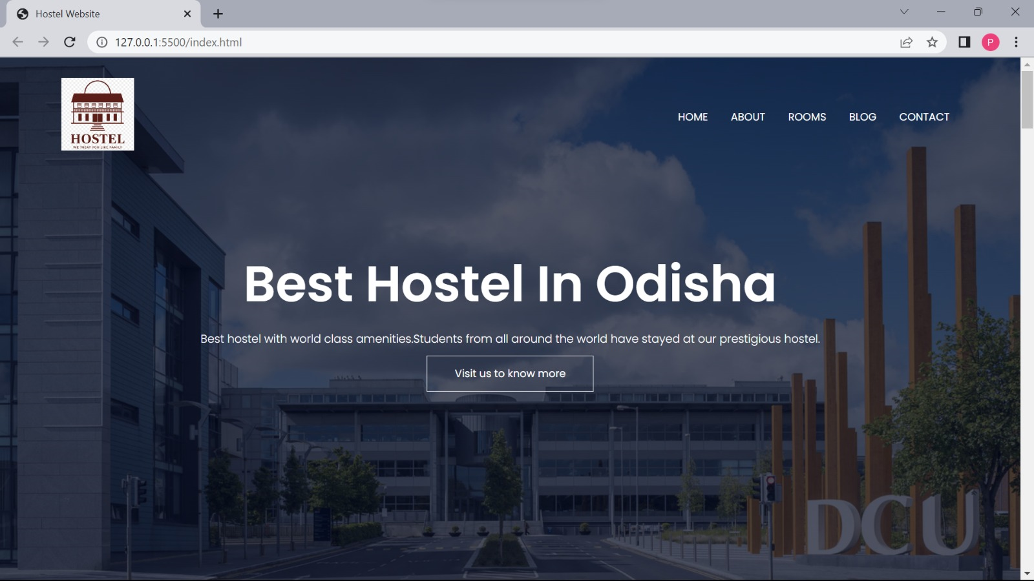

**Hostel Rooms**

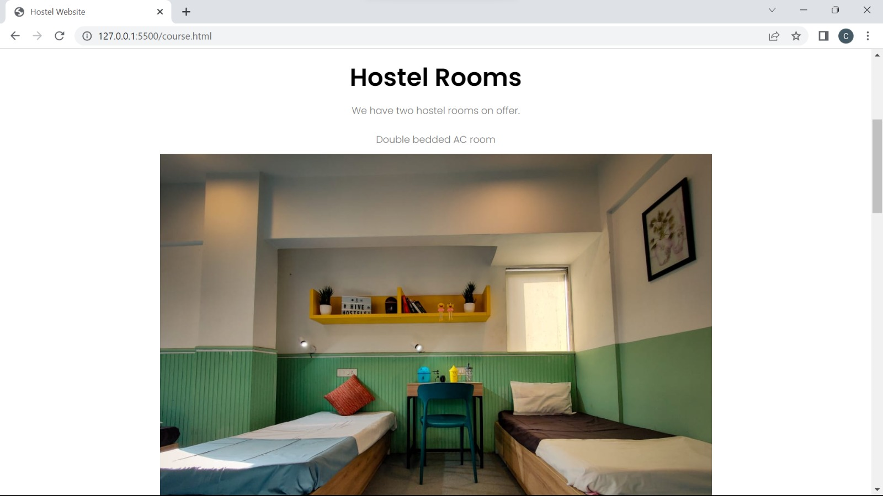

**Room Type**

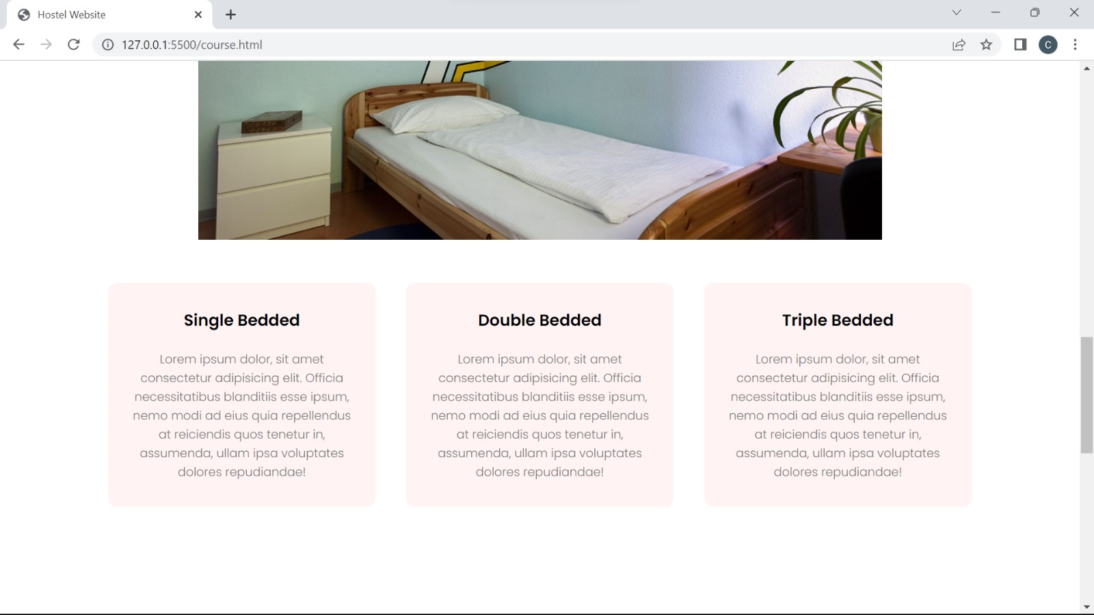

**Hostel Facilities**

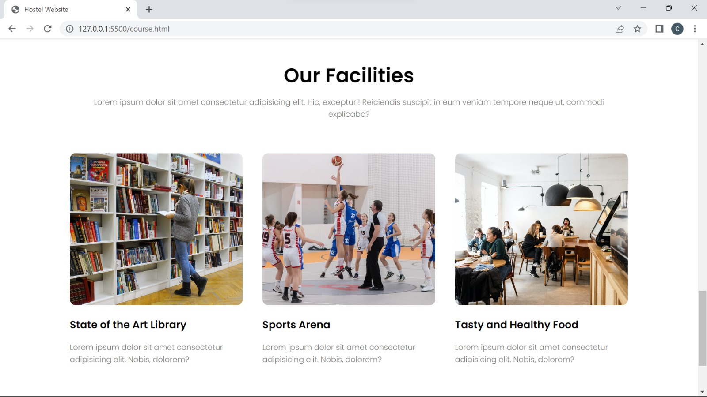

**Contact Details**

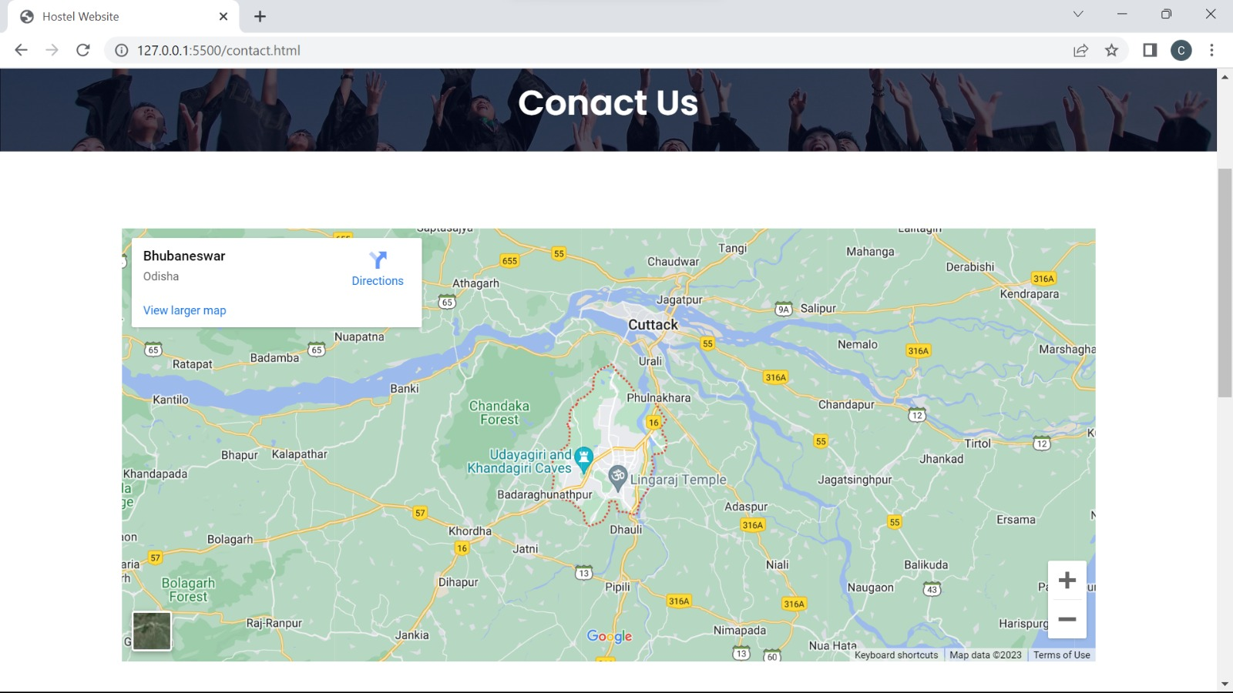

**Student Registration**

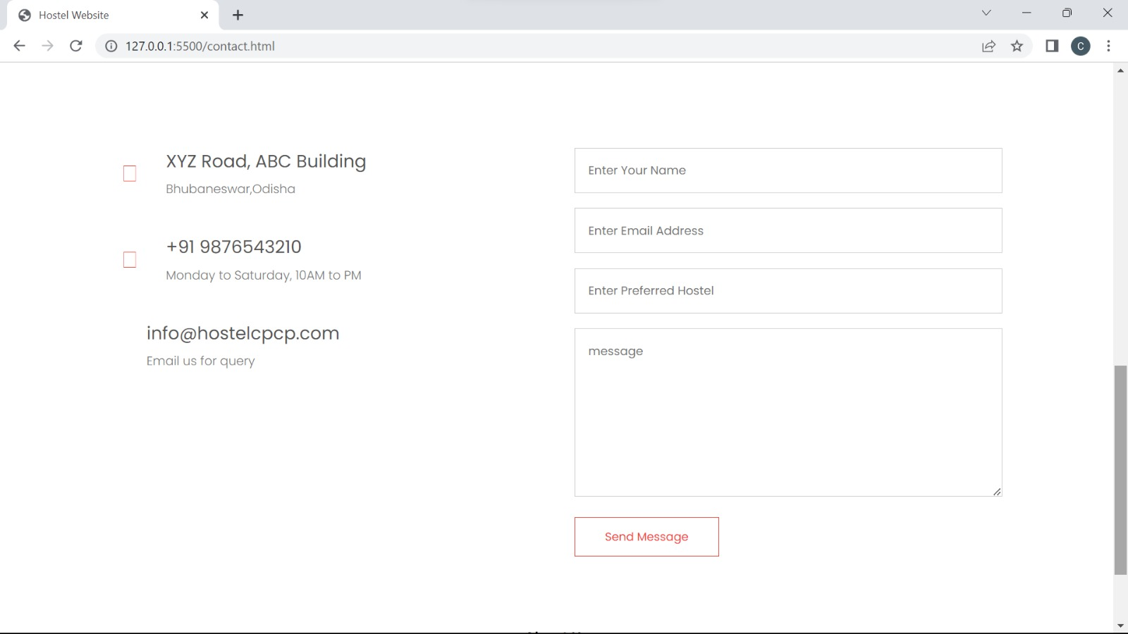

**Create Password**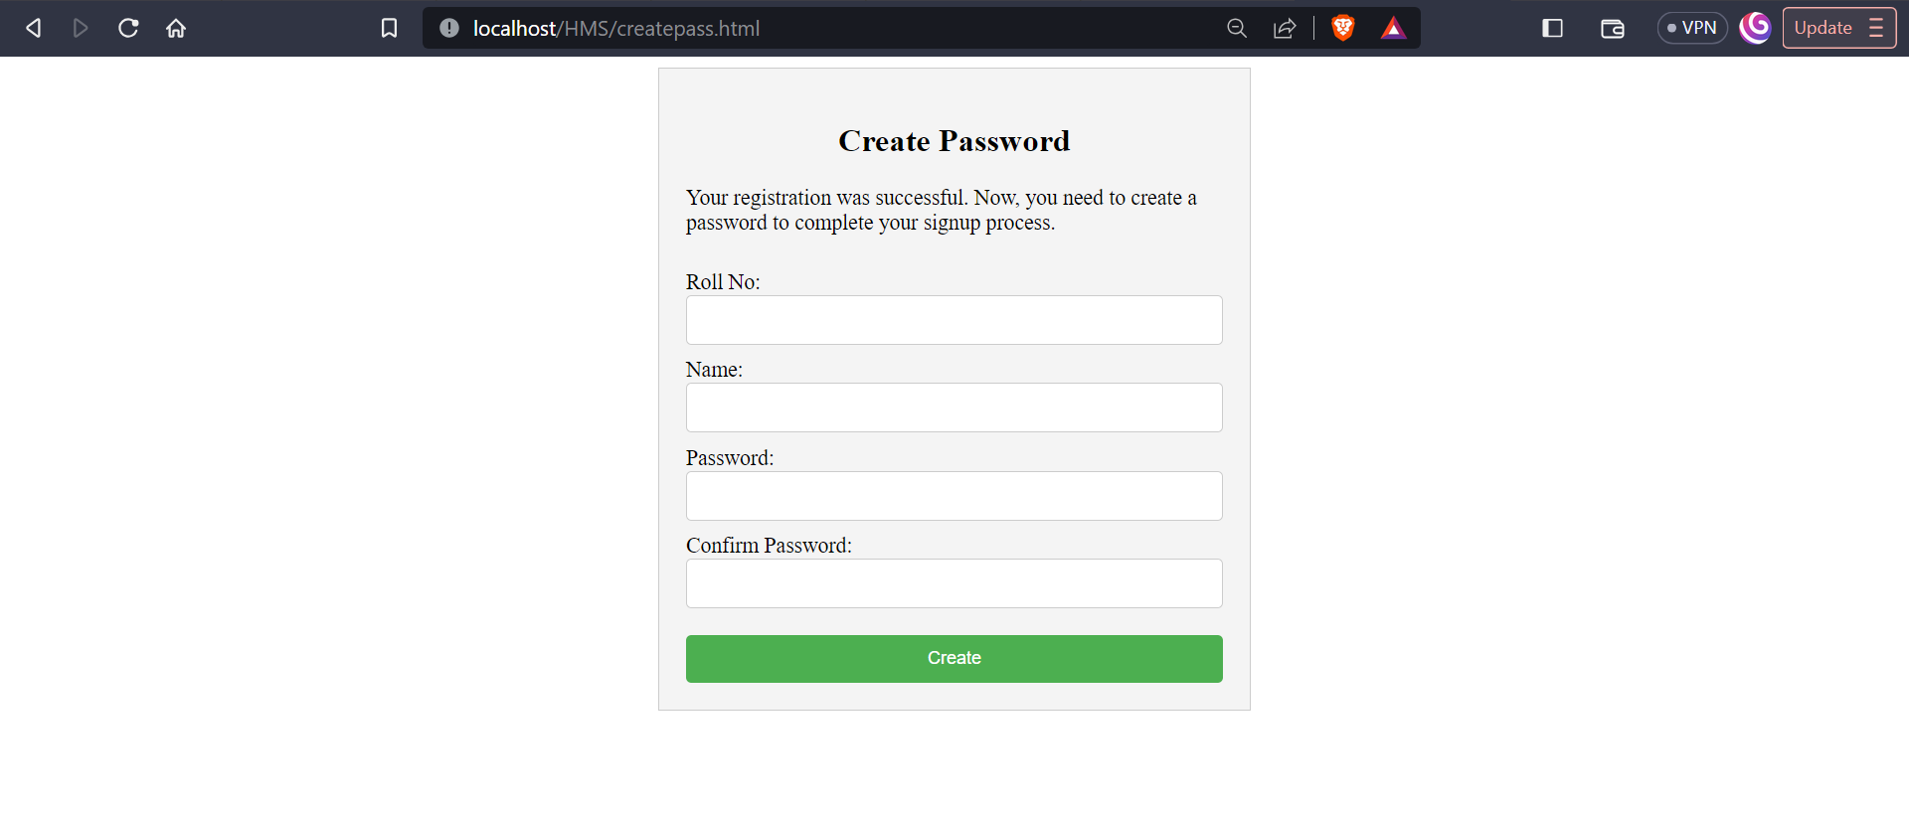

**Login** 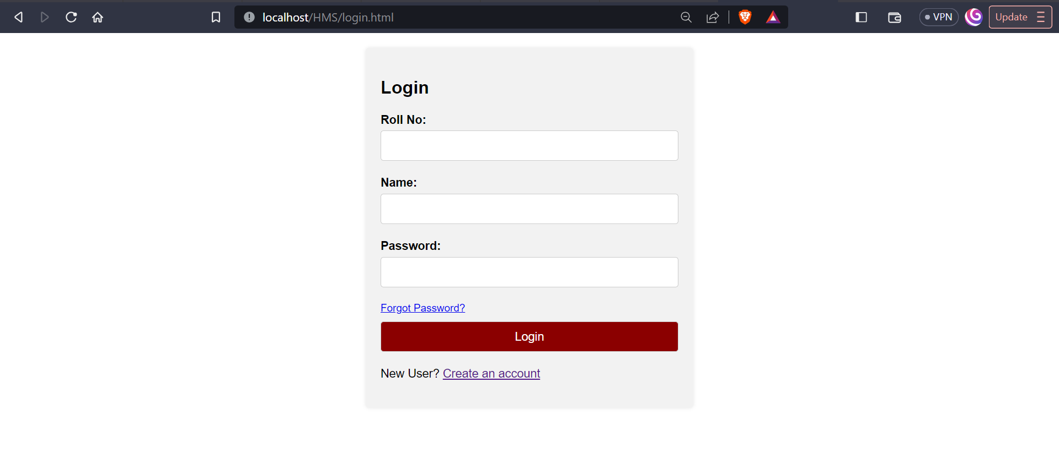

**Hostel Database**

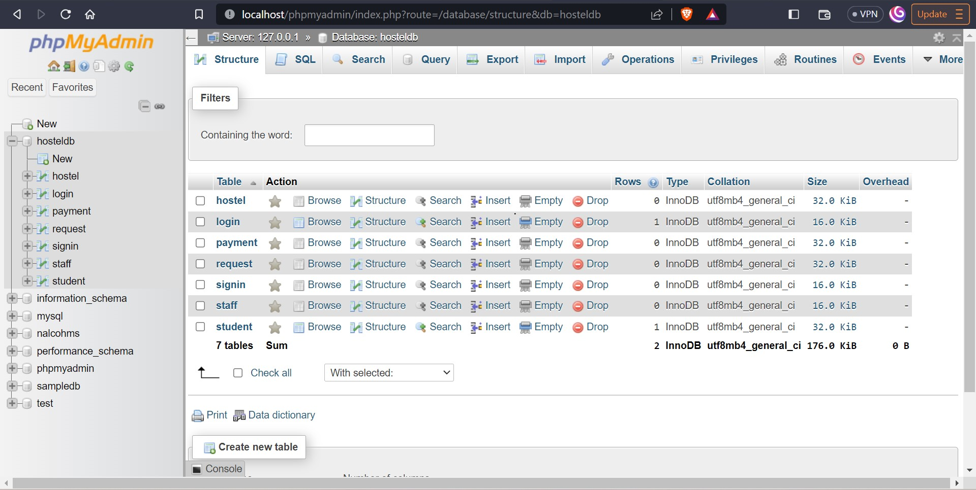

**Hostel Table**

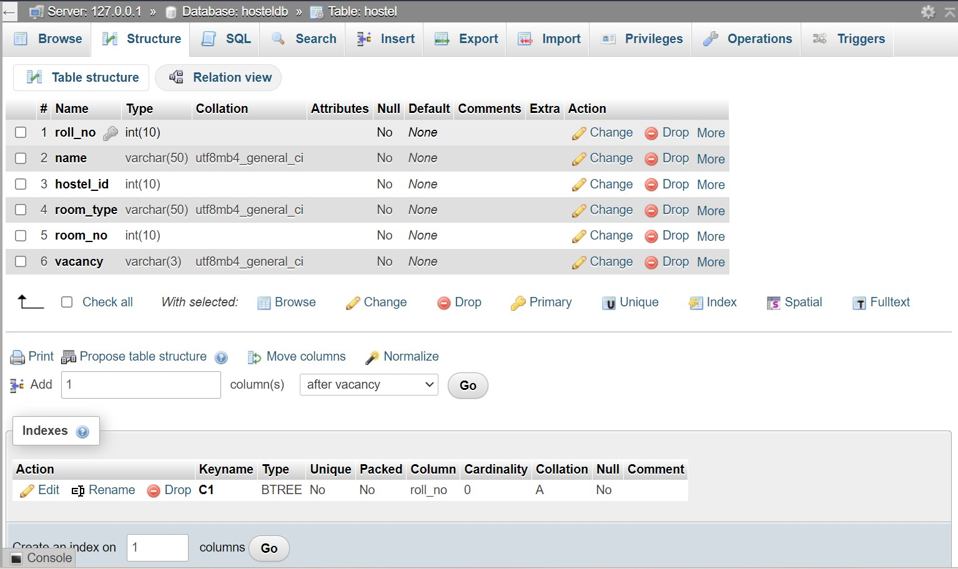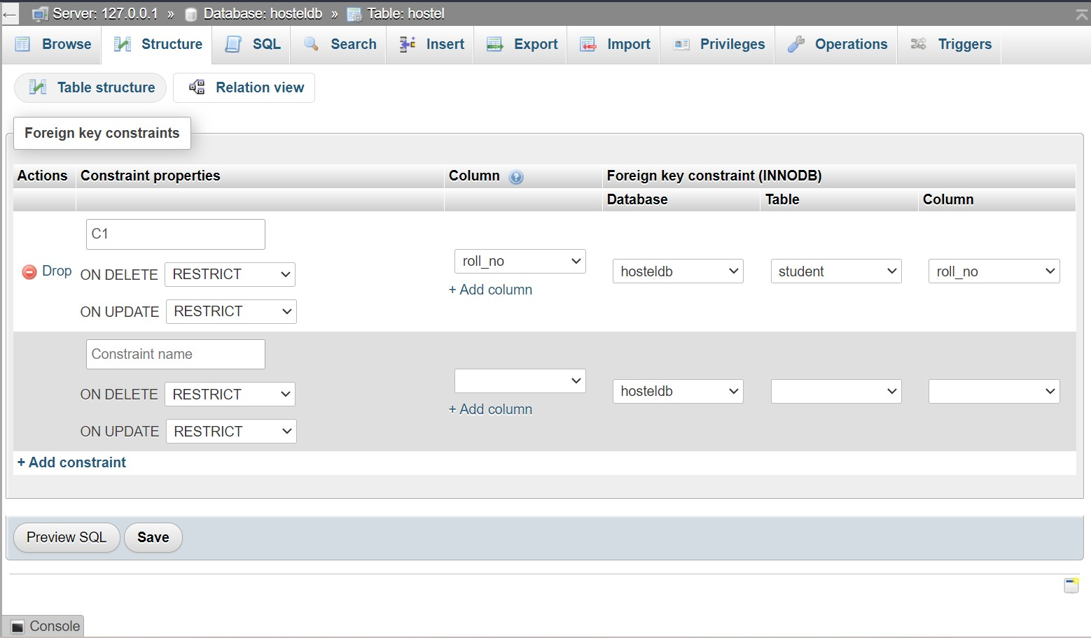

**Student Login Table**

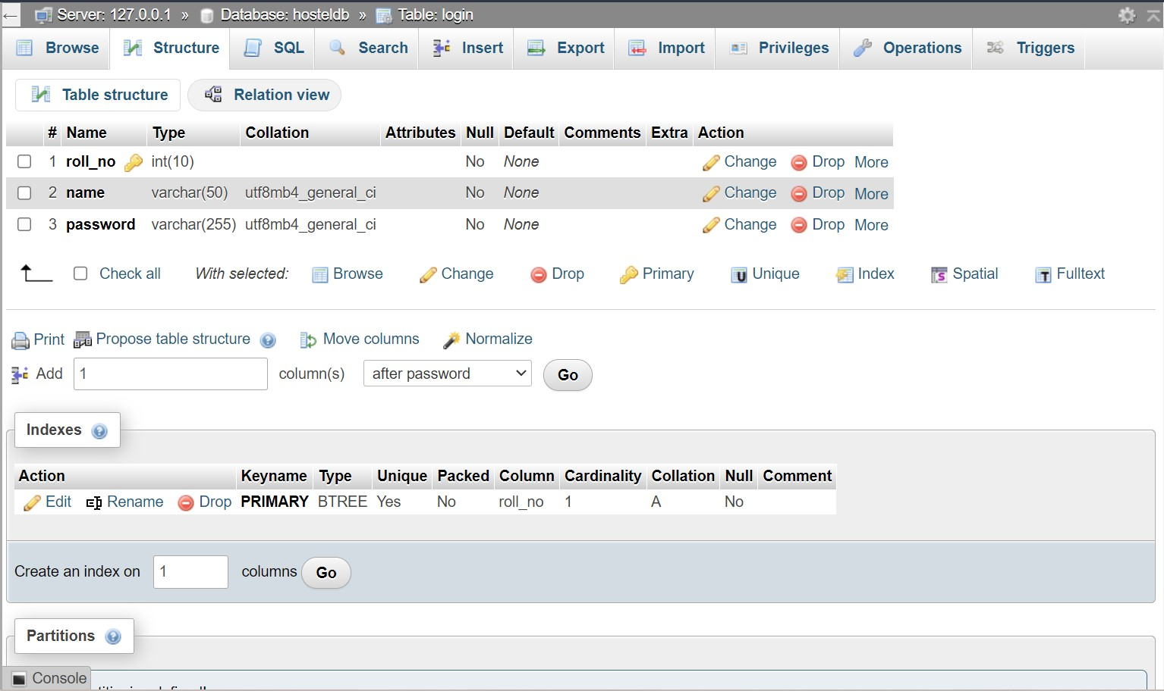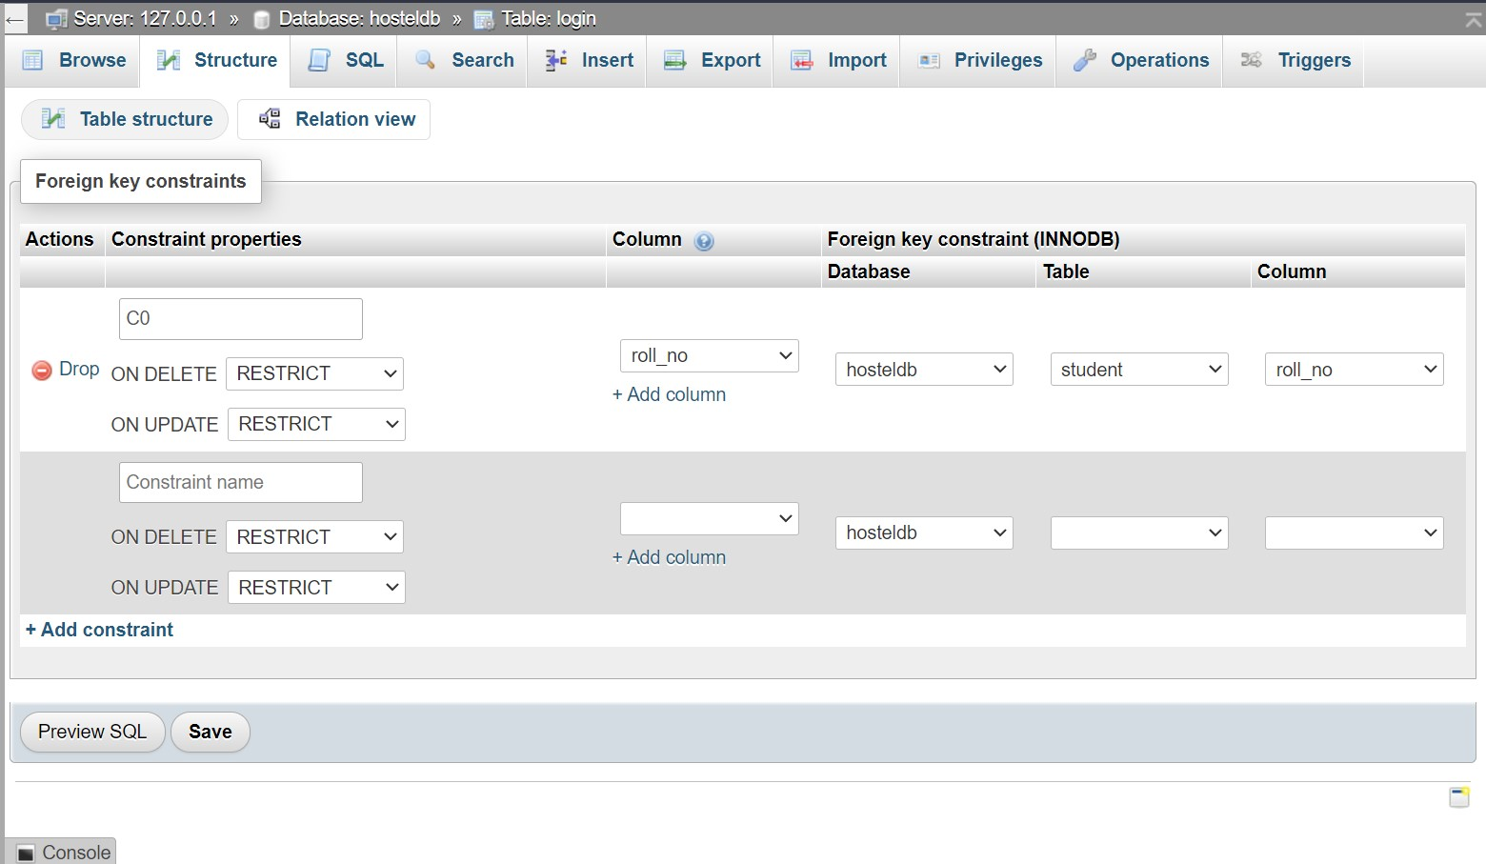

**Payment Table**

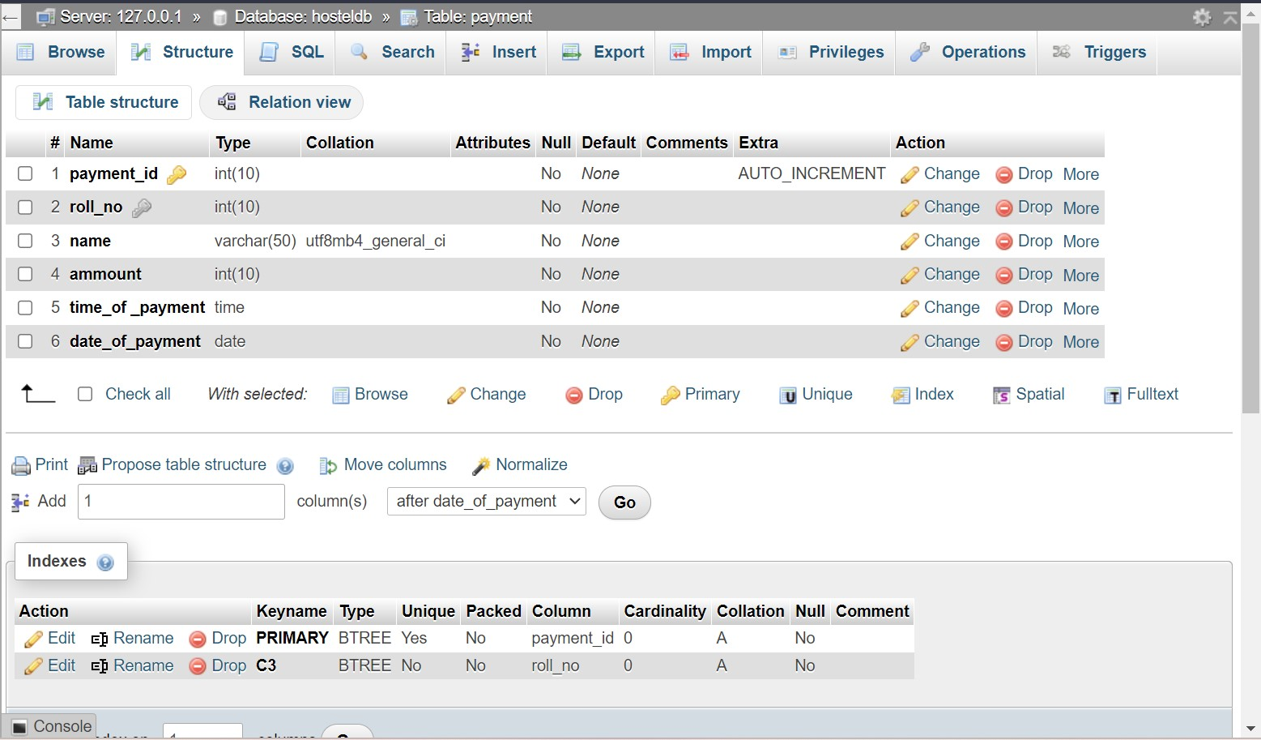

**Room Request Table**

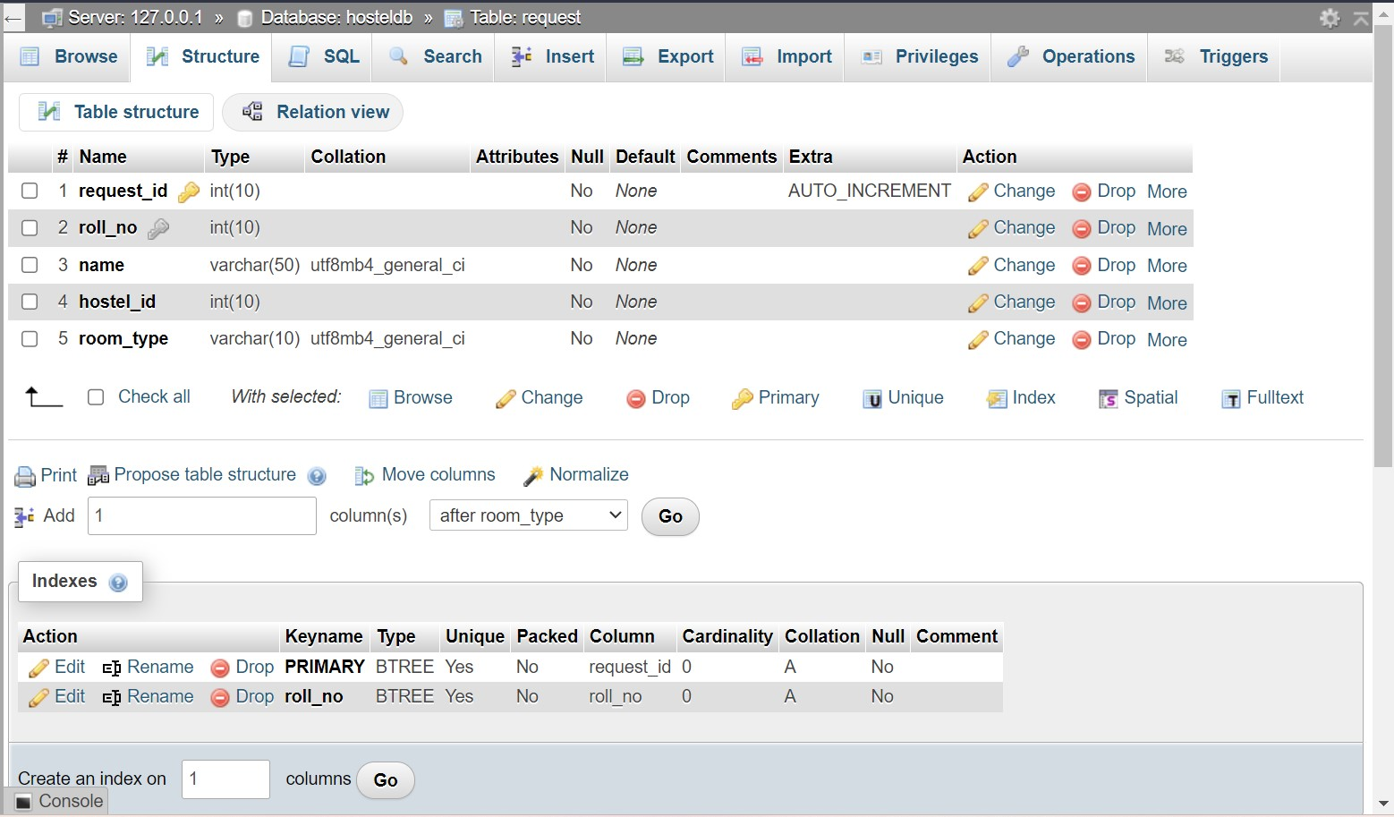

**Staff Login Table**

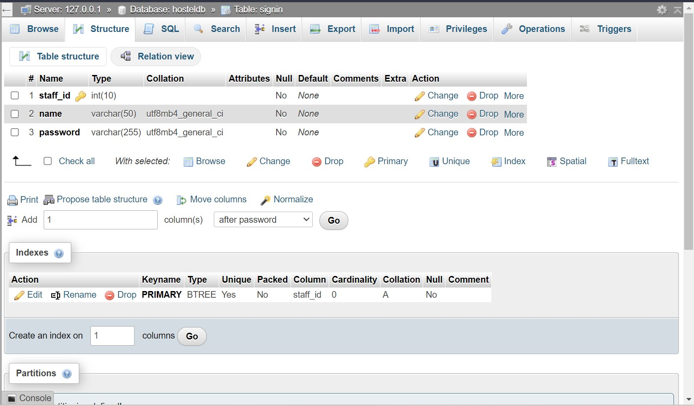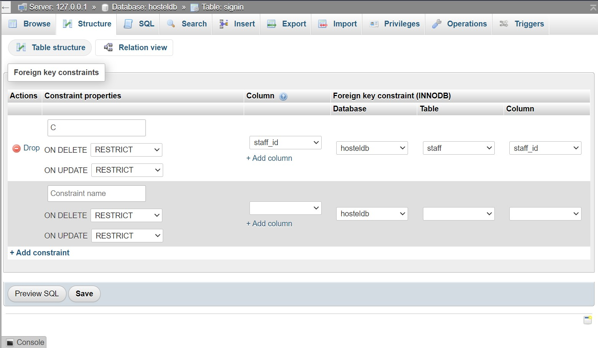

**Staff Details Table**

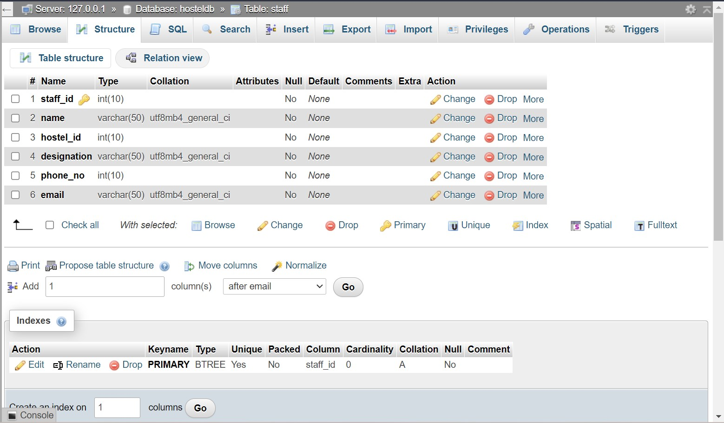

**Student Details Table**

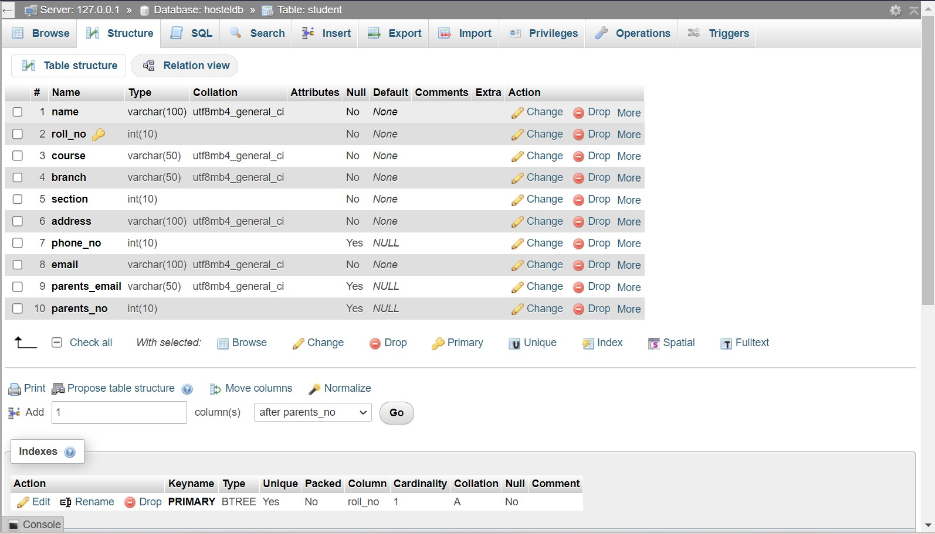

# **3. My Contribution**

The hostel website comprises five main pages: Home, About, Rooms, Blog, and Contact pages. Each page serves a specific purpose and offers unique features to engage visitors and potential students.

Home Page:

The home page acts as the website's landing page and is designed to leave a strong first impression. It includes essential details about the hostel, such as its name, location, and a brief mission statement. The primary focus is the application form, which allows prospective students to apply for accommodation. A clear call-to-action (CTA) button prompts visitors to take action and apply.

About Page:

The about page provides comprehensive information about the hostel's services, and history. A brief history of the hostel's establishment and growth is also included to build credibility.

Rooms Page:

The rooms page presents the various accommodation options available to students. Detailed descriptions of one-bedded AC rooms, two-bedded AC rooms, and three-bedded AC rooms are provided, along with pricing information. Additionally, the page emphasizes the amenities of the world-class library, huge cafeteria, and sports arena to further entice potential students.

Blog Page:

The blog page serves as a platform for student reviews and testimonials. Genuine feedback from past and current residents is displayed in an easily scannable format to build trust and credibility. Positive experiences shared by students can significantly influence potential applicants.

Contact Page:

The contact page offers various means of communication with the hostel administration. It includes complete addresses, telephone numbers, and email IDs to facilitate easy contact. A contact form is also provided, enabling visitors to send specific inquiries or messages to the hostel administration conveniently.

Design and User Experience:

The overall design of the website is carefully crafted to create an aesthetically pleasing and user-friendly experience. The interface ensures easy navigation, intuitive layouts, and consistent design elements throughout all pages. The website's responsiveness ensures optimal viewing and interaction across different devices and screen sizes, enhancing accessibility for users.

**4 Conclusion**

While developing the system, a conscious effort was made to construct and develop a software package, utilizing available tools, techniques, and resources to produce a proper system.

The system was designed with the goal of being as user friendly, cost effective, and versatile as possible. As a result, one might hope that the system will be acceptable to any user and suit his or her demands properly.

As in the case of system development procedures where there are a number of flaws, there were some flaws in the creation of this system as well.

The project is still being worked on.

There is always the possibility of future enhancements for all software. The proposed system has a few enhancements, which are shown below.

The project's scope includes the system on which the software is installed; the project is designed as a desktop application that will function for all users. However, the project can be changed later to function on a handset.

**5 References**

1. Chaudhri, Kartik, and Riddhi Kevat. "Study of Digitalized Hostel Management System." *International Journal of Scientific Research in Computer Science, Engineering and Information Technology* (2021): 366-371.

2. Chaudhri, K., & Kevat, R. (2021). Study of Digitalized Hostel Management System. *International Journal of Scientific Research in Computer Science, Engineering and Information Technology*, 366-371.

3. BC170744, Prashanth C. *HOSTEL MANAGEMENT SYSTEM*. Diss. KUVEMPU UNIVERSITY, 2020.

4. BC170744, P. C. (2020). *HOSTEL MANAGEMENT SYSTEM* (Doctoral dissertation, KUVEMPU UNIVERSITY).